Chapter 13, Solution 14.

Obtain the Thevenin equivalent circuit for the circuit in Fig. 13.83 at terminals
a-b.

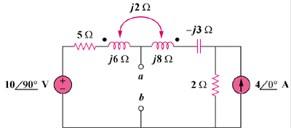

80∠0˚ A

200∠90˚ V

Figure 13.83
For Prob. 13.14.

Solution

To obtain V_{Th}, convert the current source to a voltage source as shown below.
+
–

160 V
+
V_{Th}
–

2 Ω
j2
a
b
+
–

j200 V

I
-j3 Ω
j8 Ω
j6 Ω
5 Ω

Note that the two coils are connected series aiding.

ωL = ωL₁ + ωL₂ – 2ωM

jωL = j6 + j8 – j4 = j10

Thus, –j200 + (5 + j10 – j3 + 2)I + 160 = 0

I = (– 160 + j200)/ (7 + j7)

But, –j200 + (5 + j6)I – j2I + V_{Th} = 0

V_{Th} = j200 – (5 + j4)I = j200 – (5 + j4)(–160 + j200)/(7 + j7)
= j200 – (6.4031∠38.66°)(256.12∠128.66°)/(9.8995∠45°) = j200–165.661∠122.32°
= j200 + 88.57 – j140 = 88.57 + j60 = 106.98∠34.115°

V_{Th} = 106.98∠34.12° V

To obtain Z_{Th}, we set all the sources to zero and insert a 1-A current source at the terminals
a–b as shown below.
+
V_{o}
–

2 Ω
j2
a
b
-j3 Ω
j8 Ω
j6 Ω
5 Ω

1 A

I₁

I₂

Clearly, we now have only a super mesh to analyze.

(5 + j6)I₁ – j2I₂ + (2 + j8 – j3)I₂ – j2I₁ = 0

(5 + j4)I₁ + (2 + j3)I₂ = 0 (1)

But, I₂ – I₁ = 1 or I₂ = I₁ – 1 (2)

Substituting (2) into (1), (5 + j4)I₁ +(2 + j3)(1 + I₁) = 0

I₁ = –(2 + j3)/(7 + j7)

Now, (5 + j6)I₁ – j2I₁ + V_{o} = 0

V_{o} = –(5 + j4)I₁ = (5 + j4)(2 + j3)/(7 + j7) = (–2 + j23)/(7 + j7) = 2.332∠50°

Z_{eq} = V_{o}/1 = 2.332∠50° Ω.

